
Proceedings of 4th National Conference on Recent Trends in Engineering and Technology,
24th April 2026, Adarsh Institute of Technology and Research Centre, Vita, Maharashtra, India.
ISBN: 978-81-998627-0-8

A Review Paper on - Intelligent Footstep Energy Harvesting Using IoT and AI for Smart Cities
Ms. Sanika Dale, AIML, AITRC, Vita
Ms. Srushti Sagare, AIML, AITRC, Vita
Ms. Rohini Pawar, AIML, AITRC, Vita
Ms. Prajakta Koli, AIML, AITRC, Vita
Mr. Shivam Ingale, AIML, AITRC, Vita
Assi. Prof. Ms. R.P.Bhilawade, AITRC, Vita

Abstract: The increasing demand for electricity and the growing population in urban areas have created the need for new renewable energy sources. One innovative solution is generating electricity from human footsteps using smart floor tiles. These tiles can produce small amounts of electrical energy when people walk over them. By integrating Internet of Things sensors and Artificial Intelligence, the system can monitor foot traffic, analyse energy production, and optimize energy usage.
This paper reviews IoT and AI-based smart footstep energy harvesting systems that convert mechanical energy from human walking into electrical energy. the generated energy can be used for street lights, public displays, or charging stations in urban areas such as railway stations, malls, airports, and smart city pathways. The proposed system contributes to sustainable urban infrastructure by utilizing renewable and eco-friendly energy sources.

Keywords: Footstep Energy Harvesting, Artificial Intelligence, Internet of Things, Smart Cities Renewable Energy, Sustainable Infrastructure.

1. Introduction
Cities are growing very fast, and because of this, the need for electricity is also increasing. Electricity is required for street lights, transport systems, mobile networks, and many daily activities. Most of the electricity we use today comes from traditional sources like coal, oil, and natural gas. These energy sources are limited and also cause pollution and climate change. Therefore, it is important to find new and eco-friendly ways to produce energy.
Renewable energy sources such as solar and wind power are already used, but researchers are also finding new ways to generate energy from human activities. One interesting idea is footstep energy harvesting. When people walk on special tiles, pressure is created. This pressure can be converted into electricity using devices such as piezoelectric sensors or mechanical systems. Even though one step produces a small amount of energy, places with many people walking every day can generate a useful amount of electricity.
Busy places such as railway stations, malls, airports, metro stations, and stadiums have a large number of people walking throughout the day. If energy-generating tiles are installed in these areas, the electricity produced can be used for small purposes like lighting LED bulbs, display boards, sensors, or mobile charging points.
Internet of Things (IoT) technology can be used to monitor how much energy is produced and how many people walk on the tiles. The data collected by sensors can be stored in the cloud and checked anytime. Artificial Intelligence (AI) can analyze this data and help decide the best locations to install the tiles. AI can also predict how much energy will be produced in the future.
Combining IoT and AI with footstep energy harvesting helps create a smart and eco-friendly solution for cities. This system produces clean energy and supports the development of smart cities. It helps reduce the use of traditional energy sources and supports a better and more sustainable future
3. Related Work

1. Piezoelectric Footstep Energy Harvesting:

Several researchers have studied the use of piezoelectric sensors to convert mechanical energy from human footsteps into electrical energy. These sensors generate voltage when pressure is applied, making them suitable for floors in crowded areas such as railway stations, shopping malls, and sidewalks. Studies show that footstep-powered tiles can generate measurable electrical energy that can be stored and used for low-power applications like LED lighting or sensors.

2. Smart Flooring Energy Harvesting Systems:

Researchers have developed smart floor tiles that capture energy when people walk over them. These systems usually contain piezoelectric plates, rectifier circuits, and energy storage units such as batteries or capacitors. The harvested energy can be used for small electronic devices or urban infrastructure systems. Experiments demonstrate that each step can produce small amounts of electricity which can accumulate when many people walk over the surface.

3. Energy Harvesting for IoT Devices:
Since IoT sensors are often deployed in large numbers and difficult-to-access locations, harvesting environmental energy such as vibrations or human motion can reduce the need for battery replacement.
Piezoelectric harvesting is considered a promising method for powering low-power IoT nodes in smart cities.

4. Microcontroller-Based Footstep Energy Systems:

Some research projects integrate microcontrollers such as Arduino with footstep energy harvesting systems. In these systems, piezoelectric sensors generate electricity which is then processed and regulated using electronic circuits. The energy can be stored in rechargeable batteries and used to power small devices or charging modules. These systems also include monitoring features to check sensor performance.

5. Advances in Piezoelectric Energy Harvesting:

Recent review studies have discussed improvements in materials, design structures, and energy conversion circuits for piezoelectric energy harvesting. Researchers are working on improving efficiency using advanced materials like PZT and PVDF and combining piezoelectric technology with other harvesting methods. These improvements can increase power output and make footstep energy harvesting more practical for real-world applications.

6. Energy Harvesting Floors for Smart Infrastructure

Modern research focuses on integrating energy harvesting floors with smart infrastructure systems. These systems can power street lights, sensors, or monitoring devices in urban environments. Studies show that combining energy harvesting technologies with smart city infrastructure can help reduce dependence on conventional energy sources and support sustainable urban development.
4. Methodology

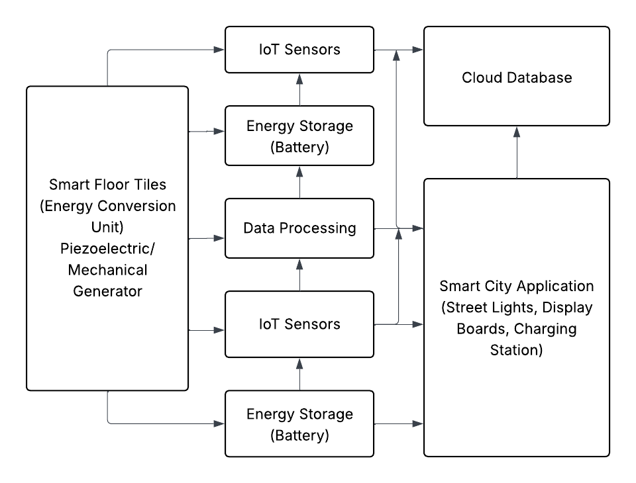
Fig: IoT and AI Integrated Footstep Energy Harvesting Architecture
5. Working

1. Footstep Energy Generation

Smart floor tiles are installed on pathways. When a person steps on the tile, mechanical pressure is generated.

2. Energy Conversion

The pressure activates piezoelectric sensors or mechanical generators that convert mechanical energy into electrical energy.

3. Data Collection using IoT

IoT sensors collect data such as:

- number of footsteps
- amount of energy generated
- peak walking hours

4. AI Data Analysis

AI algorithms analyze the collected data to:

- predict energy production
- identify high-traffic areas
- optimize energy usage

5. Energy Storage and Usage

The generated electricity is stored in batteries and used for:
- street lighting
- public display boards
- charging small devices
- powering smart city infrastructure.

6. Conclusion
Footstep energy harvesting is an innovative method of generating renewable energy in urban environments. By combining smart flooring technology with Internet of Things and Artificial Intelligence, cities can generate electricity from human movement while monitoring energy production in real time. This system can help reduce dependency on traditional energy sources and support sustainable urban development. In the future, such technologies can play an important role in building energy-efficient smart cities. By combining this system with Internet of Things (IoT) technology, it becomes possible to monitor the number of footsteps, energy generated, and system performance in real time. The collected data can be stored and analysed using Artificial Intelligence (AI) techniques to understand pedestrian movement patterns and improve system efficiency. AI can also help in identifying the best locations for installing these smart tiles in order to maximize energy generation.

7. References
- K. K. Selim, H. M. Yehia, and D. A. Saleeb, “Energy Harvesting Floor Tile Using Piezoelectric Patches for Low-Power Applications,” Journal of Vibration Engineering & Technologies, 2024.
- A. Khaligh and O. Onar, “Energy Harvesting: Solar, Wind, and Ocean Energy Conversion Systems,” CRC Press, 2017.
- J. Ghazanfarian and M. M. Mohammadi, “Piezoelectric Energy Harvesting: A Systematic Review of Reviews,” 2021.
- M. Shirvanimoghaddam et al., “Towards a Green and Self-Powered Internet of Things Using Piezoelectric Energy Harvesting,” 2017.
- I. Izadgoshasb, “Piezoelectric Energy Harvesting Towards Self-Powered IoT Sensors in Smart Cities,” Sensors, vol. 21, no. 24, 2021.
- H. Zhang et al., “Fabrication and Evaluation of Energy Harvesting Floor Using Piezoelectric Mechanism,” Sensors and Actuators A: Physical, 2018.
- X. Wang et al., “Evaluation of Harvesting Energy from Pedestrians Using Piezoelectric Floor Tile Energy Harvester,” Sensors and Actuators A, 2021.
- Y. Zhang et al., “Footstep-Powered Floor Tile: Design and Evaluation of an Electromagnetic Energy Harvesting System,” Sustainable Energy Technologies and Assessments, 2023.
- M. D. Saranya et al., “IoT Based Footstep Energy Harvesting System Using Arduino,” International Conference on Image Processing and Capsule Networks, 2024.
- A. Dahiya and R. Kumar, “A Review of Piezoelectric Energy Harvesting Tiles: Designs and Future Perspectives,” Energy Conversion and Management, 2022.
- H. S. Kim, J. H. Kim, and J. Kim, “A Review of Piezoelectric Energy Harvesting Based on Vibration,” International Journal of Precision Engineering and Manufacturing, vol. 12, no. 6, pp. 1129–1141, 2011.
- Y. Zhang and L. Wang, “Design and Implementation of Footstep Power Generation System Using Piezoelectric Sensors,” International Journal of Engineering Research and Technology, vol. 6, no. 5, pp. 415–418, 2017

